Walk 18 Views to the Urals

Description. A 7½ km (4.6 mile) hilly, moderate ramble. The walk goes thu a park, along roads and along an open hill. If you stand on the top of the Malvern Hills and look east the next highest hills are the Urals in Russia. Hereford Times July 2019.
Start. Malvern Priory Road Car Park. Opposite the swimming pool. Explorer Map OS 190 Grid 778459.
Direction from Whitecross Roundabout (Turn milometer to zero). CHECK MILAGE Take the A4110 Canon Pyon (Three Elms road). After 1 mile at traffic lights TR. Continue on the A4103 towards Worcester and at 19.3 miles TR onto the A4219 Malvern/Cowleigh Road. Continue straight on to the end of the road (21.4 miles), and at traffic Lights you TR. On reaching Great Malvern you TL and go down Church Street (????miles). Go straight over the first set of traffic lights (theatre is on the R) ignore the next R turn, and TR at cross roads (parking signs displayed) and go down Victoria Road. Straight across the cross roads and along Priory Road, to park in the car parks (L) that are opposite the swimming pool.

1. Priory Road Car Park (opposite Splash Pool). Emerge and TL along Priory Road. TO BE WRITTEN

At the L bend, cross and go up a walled footpath next to No4 Priors End. At the end, TL past Lindsay Arts Centre and TL into College Road to Malvern College. During World War II, the college premises were requisitioned by the Admiralty and the school temporarily relocated to Blenheim Palace. Continue. Bend R at Headmaster’s House, past Ashfield. Swing up L along Abbey Road, short distance to Wells Road, cross and, at 1860 fountain, TR as if for Colwall.

2. Upper Wyche Road. TL along near pavement, past Chalet No. 24 and Earnslaw Quarry, with views across Seven Plain, for one mile, to the Wyche Inn. TR, into Herefordshire, to find toilets, bus stop and bench area. But TR up Beacon Road, at Gundy’s Meadow. Follow obvious surfaced path, perhaps favouring Hensby’s right, eastern approach for gradual ascent – one mile – to

3. Worcestershire Beacon. Celebrating the Queen’s first sixty years, the topography will tell you that (RAF Defford) at Croome Park was 7 miles due east, but can you see the Ural Mountains? When ready, carry on due north quite steeply down over rougher ground, 550m, to an indicator stone. At the path junction look for the way to St Ann’s Well. Go forward five paces and TR, at the time of writing, thru a wooden gate. (Not back on yourself.) After about 75 paces, fork L down the broader path. Curve right down narrowing path, thru gorse, until you reach broad cross path. Turn sharp L. Go under trees, thru gate towards clearing and viewing area, but TR to St Ann’s Well.

4. St Ann’s Well. Continue down twisty surface to the road. TR for town centre via 99 steps (actually 95) and Rose Bank Gardens (Walenty Pytel’s Buzzards),to R of mount Pleasant. TL then fork lower R, signed Malvern Theatres. After 50m, TL in Abbey Road. TR down Church Street. Pass Priory. TR for Theatres (old Winter Gardens.) TL into Priory Park. Pass L of bandstand, across Swan Pool, by Splash to park.
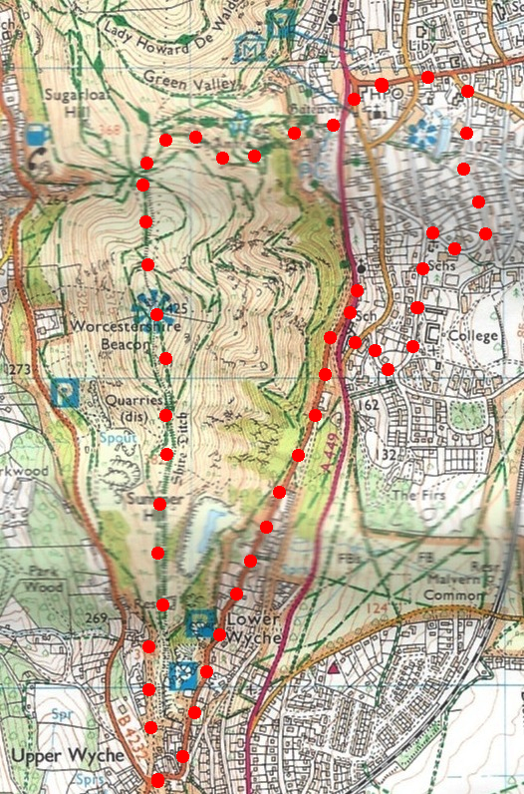

1

4

2
3

